Problem Statement
Analyze daily internet usage patterns across different age groups to understand how device type, internet connection type, and activity categories (social media, work/study, entertainment) vary with age, and derive insights that can help telecom companies and digital platforms optimize services and plans.
Questions(KPIs):
- How does total daily screen time differ across age groups?
ANS:
SELECT age_group, cast(avg(total_screen_time) as decimal(10,2)) as "Total Screen Time" from daily_internet_usage_by_age_group
group by age_group;

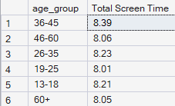

- Which age groups spend more time on:
  - Social media
ANS:
SELECT age_group, cast(avg(social_media_hours) as decimal(10,2)) as "Social Media Hours" from daily_internet_usage_by_age_group
group by age_group
order by "Social Media Hours" desc;

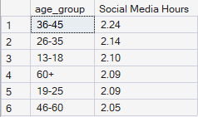

  - Work/study
ANS:
SELECT age_group, cast(avg(work_or_study_hours) as decimal(10,2)) as "Work/Study Hours" from daily_internet_usage_by_age_group
group by age_group
order by "Work/Study Hours" desc;

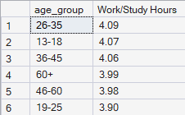

  - Entertainment
ANS:
SELECT age_group, cast(avg(entertainment_hours) as decimal(10,2)) as "Entertainment Hours" from daily_internet_usage_by_age_group
group by age_group
order by "Entertainment Hours" desc;

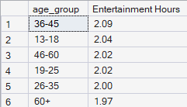

- What is the preferred device (Mobile, Laptop, Tablet) by age group?
ANS:
WITH DevicePreference AS
(
SELECT
age_group,
primary_device,
COUNT(*) AS total_users,
RANK() OVER (
PARTITION BY age_group
ORDER BY COUNT(*) DESC
) AS device_rank
FROM daily_internet_usage_by_age_group
GROUP BY age_group, primary_device
)

SELECT
age_group,
primary_device AS preferred_device,
total_users
FROM DevicePreference
WHERE device_rank = 1;

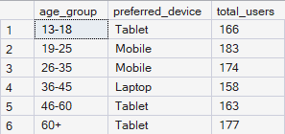

- How does internet type (WiFi vs Mobile Data) vary with age?
ANS:
Select age_group,internet_type from (select age_group, internet_type, count(*) as total_users, Rank() over (partition by age_group order by count(*) desc) as Ranked_Internet_Type from daily_internet_usage_by_age_group
group by age_group,internet_type) as t
where Ranked_Internet_Type=1;

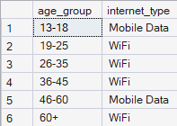

- Are younger users more dependent on mobile data compared to older users?
ANS: Based on the SQL results, younger users (13 to 18) primarily prefer Mobile Data, while users aged 19 to 45 predominantly use WiFi. Among older users, the 46 to 60 age group prefers Mobile Data, whereas the 60+ age group prefers WiFi. Therefore, the data does not support the conclusion that younger users are generally more dependent on Mobile Data than older users, as Mobile Data preference is also observed in the 46 to 60 age group.
- Which age group contributes the highest overall internet consumption?
ANS:
WITH screen_time AS (SELECT age_group, avg(total_screen_time) AS avg_screen_time FROM daily_internet_usage_by_age_group GROUP BY age_group) SELECT age_group, avg_screen_time, RANK() OVER (ORDER BY avg_screen_time DESC) AS rank_consumption FROM screen_time;

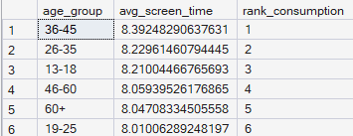

Dataset(Link)
https://www.kaggle.com/datasets/jayjoshi37/daily-internet-usage-statistics-by-age-group

Why This Problem Matters?
For a Business Context:-
Internet service providers, device manufacturers, and content platforms need to:
- Design age-specific data plans
- Optimize network usage (WiFi vs Mobile Data)
- Target users with relevant content and pricing strategies
Understanding who uses what, how much, and on which device directly impacts revenue and customer satisfaction.
Process
- Verify data for any missing values and anomalies, and sort out the same.
- Make sure data is consistent and clean with respect to data type, data format and values used.
- Created pivot tables according to the questions asked.
- Merge all pivot tables into one dashboard and apply slicer to make dynamic.

Project Insights
- Work/study hours remain relatively consistent across all age groups, averaging around 4 hours per day.
- Social media usage is slightly higher among younger age groups (13–25) compared to older users.
- Entertainment usage shows a gradual decline in users aged (60+), indicating lower recreational screen time.
- Working-age groups (26–45) demonstrate balanced usage across work and entertainment activities.
- The (36–45) age group records the highest average total screen time, driven by combined work and entertainment usage.
- Moderate users form the largest segment across all age groups, indicating balanced daily internet usage patterns.
- Heavy internet users are more concentrated in the (26–45) age range, suggesting higher screen dependency among working-age users.
- Light usage is comparatively higher among younger (13–18) and older (60+) users, reflecting lower sustained screen engagement.
- Mobile data usage is relatively higher among the (13–19) and (46–60) age groups, indicating greater reliance on cellular connectivity within these segments.
- Tablet usage is relatively higher among the (13–19) and (46+) age groups, suggesting niche but distinct usage patterns across younger and older users.
- Laptop usage peaks among the (26–45) age group, aligning with professional and work-related usage patterns.
- Mobile devices are most preferred among the (19–35) age group, indicating higher responsiveness to mobile-centric products and campaigns within this segment.
- Majority of age groups prefer WiFi over Mobile data which indicates home based usage, useful for broadband service planning.
- These patters suggest targeted device-based marketing could be effective by age group.

Final Conclusion:
This analysis explored daily internet usage patterns across different age groups by examining activity distribution, usage intensity, device preference, and internet connectivity types. The findings indicate consistent work/study usage across ages, with variations in social, entertainment, and overall screen time driven primarily by age and lifestyle differences. Working-age users (26–45) exhibit higher overall and intensive usage, while younger and older groups show more light and selective usage patterns. Device and connectivity preferences further highlight age-specific behaviors, with mobile, laptop, and WiFi usage varying across demographic segments. Overall, the analysis demonstrates how structured exploratory analysis and visualization can be used to derive meaningful insights into user behavior from raw usage data.

Description:
I had developed a comprehensive project using Microsoft Excel and SQL, I had created insightful Dashboard using PowerBI I used slicers to analyze and properly showcase the data. This process involves several stages including data processing, data cleaning and data visualization.

